FINAL INSIGHTS, RECOMMENDATIONS, AND ANALYSIS OF ONLINE RETAIL DATASET

Shivam Trivedi
University of the Cumberlands
Advanced Big Data and Data Mining (MSCS-634-B01)
Dr. Satish

22nd April 2026

Contents
1.0 Introduction 3
2.0 Dataset Description 3
3.0 Preparation and Preprocessing of Data. 4
3.1 Handling Missing Values 4
3.2 Outlier Treatment 4
3.3 Feature Engineering 4
4.0 Exploratory Data Analysis (EDA) 5
4.1 Sales Trends Analysis 5
4.2 Product Performance 6
4.3 Geographic Distribution 6
4.4 Price Distribution 7
4.5 Correlation Analysis 8
5.0 Analytical Methods and Modeling. 8
5.1 Regression Analysis 8
5.2 Classification Analysis 9
5.3 Clustering Analysis (K-Means) 9
5.4 Association Rule Mining 10
6.0 Key Insights 10
7.0 Recommendations 11
8.0 Ethical Considerations 11
9.0 Conclusion 12
10.0 References 13

FINAL INSIGHTS, RECOMMENDATIONS, AND ANALYSIS OF ONLINE RETAIL DATASET

1.0 Introduction
E-commerce is growing at a tremendous rate, and it has generated huge amounts of transactional data, on which organizations can leverage data analytics and machine learning techniques to enhance the customer experience and decision-making. The purpose of this project is to analyze the data of online retail to obtain valuable information on customer behaviour, product performance, and sales patterns. The dataset was selected due to the enrichments of transactional characteristics, i.e., customer purchases, products, geographic distribution, and very easy to employ high-order analytical tools.
The primary goal of the project is to demonstrate how to use data preprocessing, exploratory data analysis (EDA), feature engineering, and machine learning (regression, classification, clustering, and association rule mining) solutions. All these methods enable a transformation of raw data into an operating business intelligence. According to Provost and Fawcett (2023), modern organizations, which aim to be in the vanguard of their competition, must take data-driven decision-making.

2.0 Dataset Description
The data used in this project is a collection of transactional data from an online shop. It contains such variables as CustomerID, InvoiceDate, Quantity, UnitPrice, Country, and TotalPrice. Moreover, the feature engineering of derived variables such as Recency, Frequency, Monetary value, Average Basket Value, and Total Items Purchased was created.
The data set itself is a replica of the purchasing trend of different countries, with the United Kingdom contributing the majority of the transactions and revenues. This makes the dataset highly valuable in the analysis of geographical trends and segmentation of customers. They can both be analyzed in a holistic way, through the assistance of descriptive and predictive analytical tools, both structured numeric and categorical variables (Shmueli et al., 2022).

3.0 Preparation and Preprocessing of Data.

3.1 Handling Missing Values
One of the factors that defines the reliability and accuracy of the results of the analysis is the preprocessing of data. One of the key issues that was identified in the dataset was the presence of missing values, particularly the CustomerID variable, which had approximately 24.55% of the missing values. In order to maintain data integrity and avoid introducing any bias in the analysis, the missing values were treated by removing the incomplete records.

3.2 Outlier Treatment
The outliers were noted in the Unitprice variable, which consisted of extreme values that can skew the statistical analysis and also the model performance. To address this, the unit prices were reduced at a threshold value, such that the extreme observations would not influence the results disproportionately. This approach complements the best rules of data preprocessing, where extremes are addressed to make the models more robust (Han et al., 2022).

3.3 Feature Engineering
Feature engineering was performed to enhance the dataset and to boost the analytical capability. The primary keys created are Recency, a measurement of time since the customer has been buying items, Frequency, the number of purchases, and Monetary value, the amount of money that the customer has spent. Other attributes, such as Average Basket Value and Total Items Purchased, were also calculated to have a better understanding of customer purchasing behavior. These engineered features form the basis of segmentation and predictive modeling.
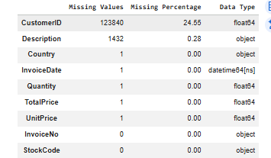

4.0 Exploratory Data Analysis (EDA)

4.1 Sales Trends Analysis
The exploratory data analysis revealed that the sales performance trends over time were important. Monthly sales trends were found to be inconsistent, with the sales being found to increase towards the later months of the year. It means that it may be partly seasonal, i.e., there are periods with a high demand caused, perhaps, by holidays or promotions. These trends are significant in making predictions and planning inventories.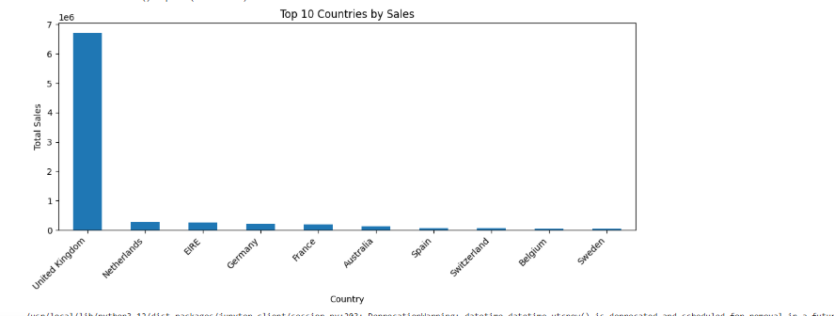

4.2 Product Performance
Analysis at the product level revealed that few products managed to bring about a large percentage of the total sales. Other products that were best-selling products were decorative and storage products. The extreme concentration of demand, such as this one, proves that there is a need to seek high-performance products and ensure that the inventory is kept in a certain manner.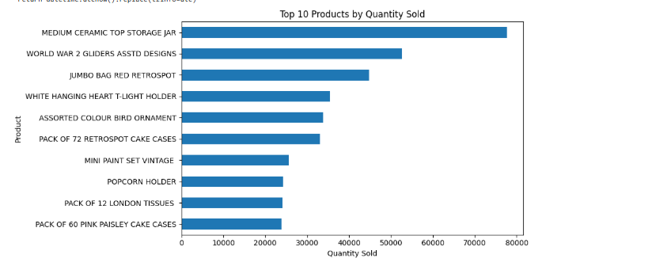

4.3 Geographic Distribution
This data revealed that the level of geographic concentration was high, with the United Kingdom dominating the total sales. The other parts of the globe, such as the Netherlands, Germany, and France, made minimal contributions. This kind of unequal distribution will mean that it is dependent on some markets, and this may be dangerous in case of market alterations.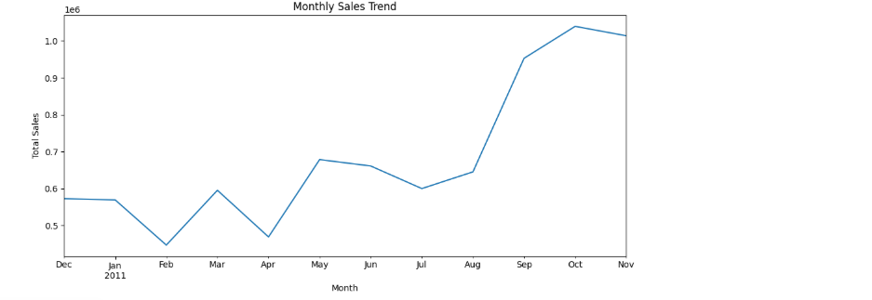

4.4 Price Distribution
The unit price distribution was mostly in the form of low-cost products with a few high-value outliers. This is a biased distribution characteristic of retail data, and it represents that the business relies on high-volume, low-profit sales to generate income.
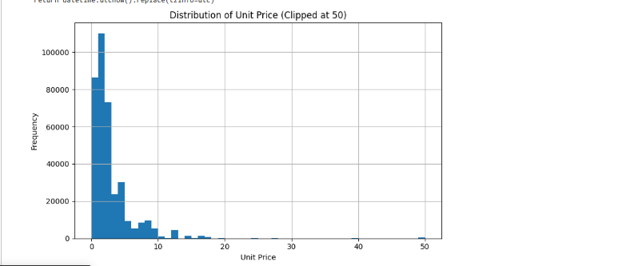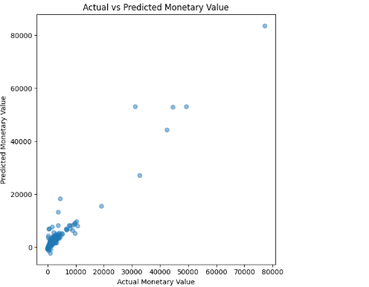

4.5 Correlation Analysis
Correlation statistics provided the data on the relation between variables. Frequency, Monetary value, and Total Items Purchased had positive correlations (r=2.02, r=2.02, r=2.02). This means that the customers purchasing more would spend more, hence the importance of customer retention strategies.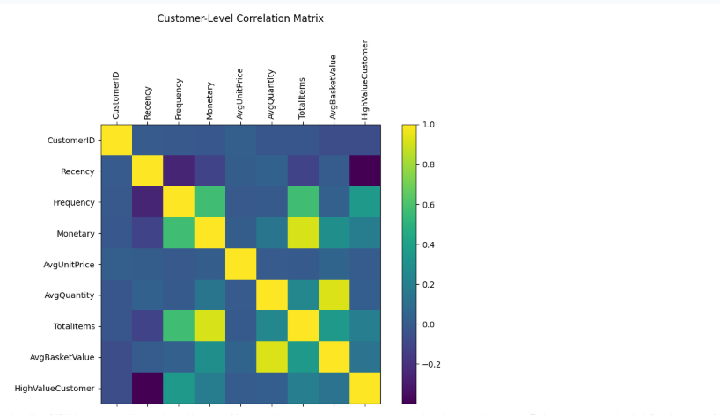

5.0 Analytical Methods and Modeling.

5.1 Regression Analysis
The customer monetary value, as predicted by the regression model, was determined through engineered features such as Frequency and Average Basket Value. The predictive capacity of the model was moderate since it could capture the broad trends but was unable to predict extremely high-value transactions. The phenomenon of outliers and variability of customer spending behavior can be attributed to this weakness. Witten et al. (2023) mention that regression models require delicate fine-tuning, with features being chosen to make them work better on complex data.

5.2 Classification Analysis
The classification techniques were used to classify customers into high-value and low-value customers. The model was found to be rational in the process of identifying high-value customers, which is highly crucial in particular marketing and resource allocation. Focusing on high-value customers will help businesses to get the greatest ROI and increase the customer lifetime value.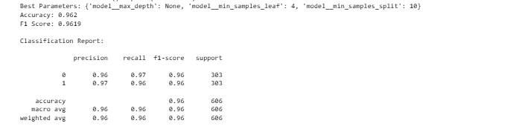
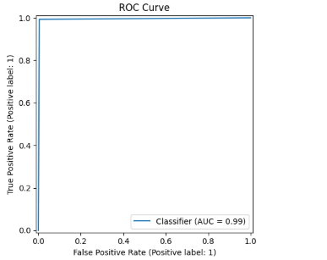

5.3 Clustering Analysis (K-Means)
The K-Means clustering based on purchasing behavior was utilized to divide the customers into groups using the clustering. The elbow method has demonstrated that four clusters gave optimal segmentation. These groups represented various groups of customers, like the high-value frequent customers, moderate customers, occasional customers, and inactive customers. The significance of customer segmentation is that it helps companies address the needs of specific customers with their products (Shmueli et al., 2022).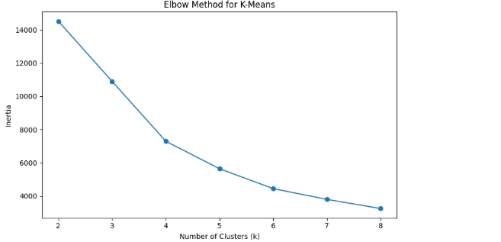

5.4 Association Rule Mining
The association rule mining was applied in determining the association between products that are widely purchased. This analysis determined the trends that may be applied in cross-selling and product bundling. An example of this would be clients who purchase decorative items who would also be likely to purchase complementary products. They can be applied in marketing strategies and recommendation systems.

6.0 Key Insights
Several useful insights were gained in the analysis. Firstly, the number and the frequency of transactions have a significant influence on the customer buying behavior, in which a minor percentage of customers would result in a huge percentage of total revenue. Second, seasonal patterns play a very important role in the sales performance, and there must be an efficient demand forecasting. Third, product demand is agglomerated on a limited number of the best-selling products, hence making inventory optimization significant. Finally, geographic concentration means that it relies on some markets that can be diversified with the help of diversification practice.

7.0 Recommendations
Based on the findings, we can draw several recommendations that can be made in practice. The companies should embrace the strategies of customer segmentation in order to offer tailor-made marketing campaigns that would be applicable to the different groups of customers. High-value customers should be provided with loyalty programs and special offers to enhance retention. The inventory should be operated in such a way that it concentrates on the high-demand products and reduces low-performing stocks so as to achieve the highest operational efficiency.
In addition, we can also make use of dynamic pricing, where we can change the prices based on the customer segments and patterns of demand. Geographic expansion should be considered to reduce the dependence on a single market and explore new geographic regions of growth. Finally, the association rule mining is to be employed to enhance the cross-selling efforts, as it will increase the average transaction value and customer experience.

8.0 Ethical Considerations
Ethics has been an important component of data analytics initiatives. This study did not use any personally identifiable data, which ensured data privacy. However, the results of the models can be influenced by potential biases in the data, such as the dominance of the customers of the United Kingdom, and the applicability of the models is limited. This supports the importance of considering data representativeness when developing predictive models.
The entire data processing and modeling procedures were recorded and made transparent so that the process can be reproducible and answerable. Further, the analysis must be applied in a conscientious manner to enhance customer experiences and not dictate consumer behavior. Chen et al. (2022) state that ethical data practices are central to building trust and business sustainability in the long term.

9.0 Conclusion
This project shows how data analytics and machine learning can be put into practice on real-life data from online retail. The valuable insights were acquired through data preprocessing, exploratory analysis, and other modeling techniques that can be utilized in making strategic decisions. The findings suggest customer segmentation, data-driven marketing, and continuous improvement as being important in predictive modeling.
More advanced methods of machine learning, such as deep learning and real-time analytics and integration with recommendation systems, could be applied in the future. Overall, this project showcases the disruptive quality of data analytics in the modern business environment and its role in innovation and competitive advantage.

10.0 References
Chen, H., Chiang, R. H. L., & Storey, V. C. (2022). Business intelligence and analytics: From big data to big impact. MIS Quarterly, 46(2), 1165–1188.
Han, J., Pei, J., & Kamber, M. (2022). Data mining: Concepts and techniques (4th ed.). Morgan Kaufmann.
Provost, F., & Fawcett, T. (2023). Data science for business (2nd ed.). O’Reilly Media.
Shmueli, G., Bruce, P. C., Yahav, I., Patel, N. R., & Lichtendahl, K. C. (2022). Data mining for business analytics (3rd ed.). Wiley.
Witten, I. H., Frank, E., Hall, M. A., & Pal, C. J. (2023). Data mining: Practical machine learning tools and techniques (5th ed.). Morgan Kaufmann.

